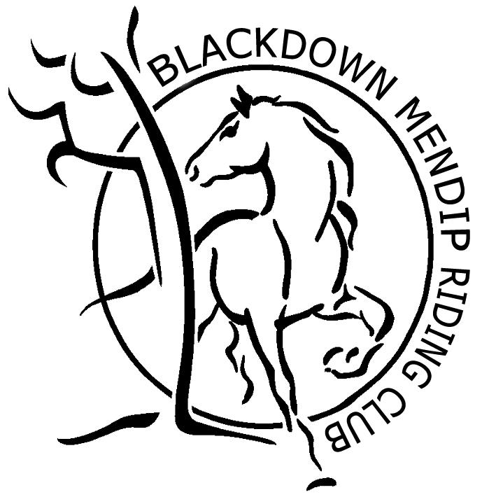
MEMBERSHIP
APPLICATION
FORM 2019

Please complete in BLOCK CAPITALS and BLACK INK
Title: |  | Date of Birth:
Forename: |  | Daytime Tel:
Surname: |  | Evening Tel:
Address Line 1: |  | Mobile Tel:
Address Line 2: |  | Parent’s Mobile
Town/City: |  | Membership:  (Please circle) | New or Renewal
Postcode:

Email:

Membership Type:  (Please Circle) | Senior Junior Family Non Rider Honorary  £28 £23 £45 £15 Free
Junior members should be 17yrs of age or younger on the 1st January on year of joining.
Family memberships are one senior and one junior member.
Payment Type:  (Please Circle) | Cheque BACS Cash Voucher
Cheques should be made payable to Blackdown Mendip Riding Club or BACS to Account: 71442384 Sort Code: 40-17-49.

I hereby agree to abide by Blackdown Mendip Riding Club Constitution - www.blackdownmendiprc.co.uk/constitution, and understand the information I have supplied will be held on the Club database. I am happy for any photographs taken to be used in event reports and publicity for the Club, which may include facebook.

Signed: |  | Date:

Please send completed/signed form to either membership@blackdownmendiprc.co.uk or Claire Scoble, Lady Farm, Chelwood, Bristol, BS39 4NN

Confirmation of membership will be sent via email. Membership cards will be sent directly from British Riding Club HQ.

FOR OFFICE USE ONLY
Date Received: |  | BMRC No.: |  | BHS: |  | BMRC LTR:

