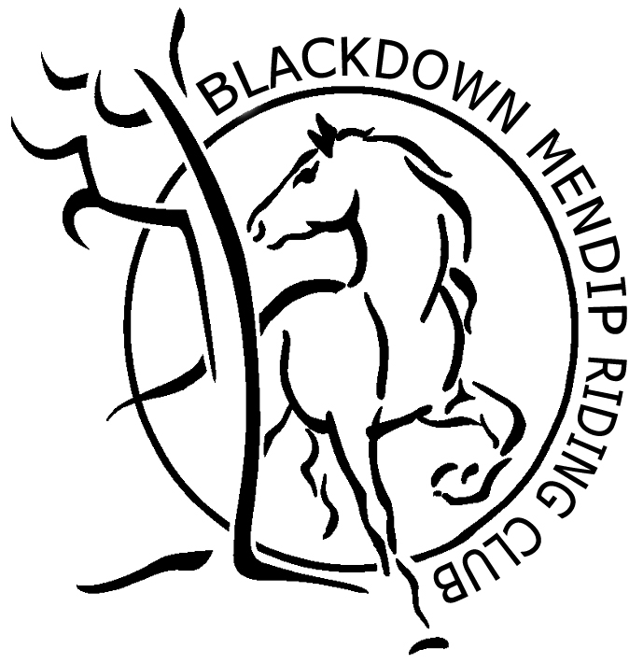 | Blackdown Mendip Riding Club Privacy Notice  For use on all membership, entry and booking forms

Your Personal Information

Personal information that you supply to us may be used in a number of ways to facilitate your riding club membership. It should be noted that as we are affiliated to the British Horse Society as a British Riding Club, your personal information will be shared with them in order to fulfil your BRC membership benefits and they may share with associates for the purpose of fulfilling your full membership benefits i.e. insurance providers.
We / BRC will automatically contact you about your membership: for example, to ensure you receive your membership benefits, to tell you about news, activities and events. This includes sending you a regular newsletter, email updates, information on other membership benefits, and publishing competition times and results in the public domain.

[29 June 2018]

To see our full Privacy Policy, or if you need any further information, please write to us at; Blackdown Mendip Riding Club or go to: [insert link to privacy policy on website here]

You may also wish to add if applicable to your organisation:
We may also, subject to your consent, use your personal information to contact you about our events, training, camp, merchandise and how you can support us, including fundraising. To receive this information please indicate your contact preferences below:
Post Email SMS Phone

Additionally, we may (subject to your consent) disclose your personal information with trusted service providers and selected partners so that they can contact you with information about their products and services. But don't worry; your details won't be shared without your consent. If you agree to your information being shared in this way, please tick this box ⃣

